**Report for 3rd August, 2017**

The following code was written to retrieve the zero crossing data from the circuit.

*// Code to detect Zero Crossing:*

*unsigned long int currentMillis, previousMillis;*

*unsigned long int lastMicros=0;*

*double freq;*

*int enable=4; //To enable ZCD module*

*void setup() {*

*Serial.begin(115200);*

*pinMode(2,INPUT_PULLUP);*

*pinMode(enable,OUTPUT);*

*digitalWrite(enable,HIGH); //ZCD enabled if HIGH*

*attachInterrupt(digitalPinToInterrupt(2),ZCD,RISING);*

*}*

*void loop() {*

*if(micros()<500000){ //Loop runs for 500 milliseconds to sample non ZCD values*

*//Serial.print(micros());*

*//Serial.print("\t\t");*

*Serial.println("0");*

*}*

*}*

*void ZCD(){*

*if (micros()<500000){ //Loop runs for 500milliseconds to sample the ZCD values at interrupt*

*// Serial.print(micros());*

*// Serial.print("\t\t");*

*Serial.println("1");*

*}*

*freq=1000000/(2*(micros()-lastMicros)); //calculating Frequency of the AC input*

*//Serial.println(freq);*

*lastMicros=micros();*

*}*

The values were collected from the Adruino IDE’s serial monitor and were imported into Matlab. And then the following graph was plotted.

**MATLAB GENERATED GRAPH:**

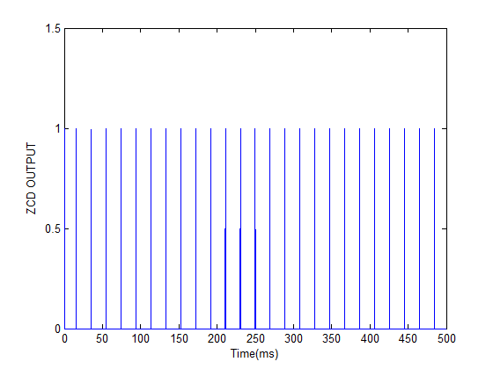

The circuit was implemented wrong, I realized it a little late. The frequency is suppose to be doubled with respect to the AC mains at approximately 100hz. But according to the graph the frequency is at 50hz. That means the circuit is not being able to detect zero crossing for 1 half of the cycle.

**Circuit:**

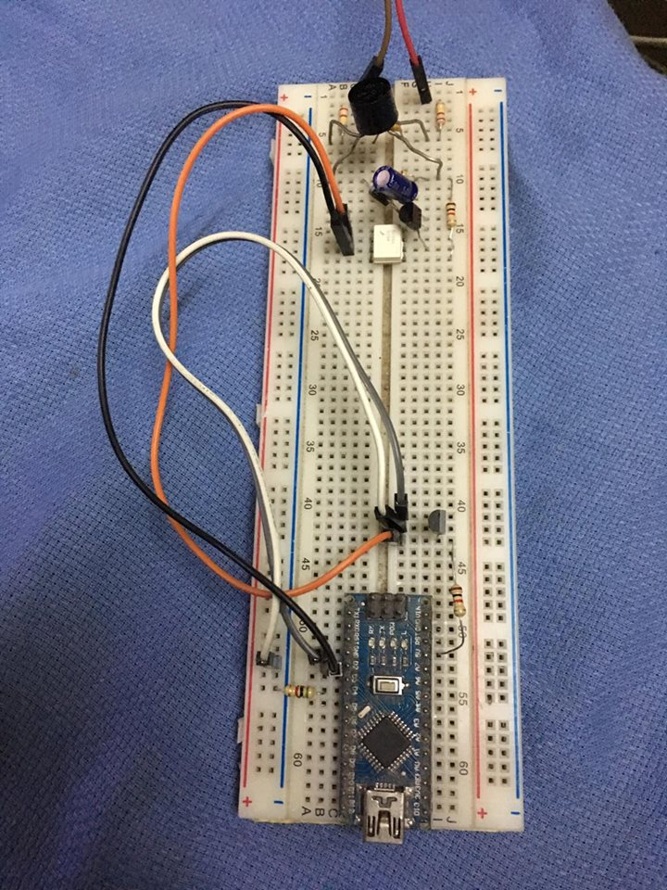

**Minor tweak:**

Added an enable port to enable and disable the zero crossing interrupt using an NPN transistor. So the output of the ZCD is passing through the transistor to the microcontroller. For this configuration, if I give a logic HIGH to the transistor’s base, the microcontroller’s interrupt will trigger. If it is logic LOW there will be no data sent to the microcontroller. This tweak was made so that the interrupt does not cause any disturbance when data is being sent or received from the internet.

**In other news:**

Ordered 2 types of energy measurement IC:

1. **ADE7758**
2. **MCP39F511**

Wanted to order a 3rd one which is **MAXQ314** that communicated using I2C communication but that got too expensive relative to the project at approximately $12 each. While the rest are priced at around $2 each. The ICs are expected to be here within 2 weeks.

Also, learning to use Python for creating TCP sockets to send and receive data. And also to generate Database using the MySQL library that comes with it to import and retrieve data.